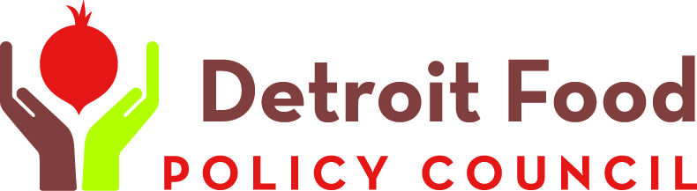
Contact Olivia Henry  Telephone 313-833-0396  Email olivia@detroitfoodpc.org  Website www.detroitfoodpc.org | FOR IMMEDIATE RELEASE  October 6, 2016

dfpc Welcomes the next generation of food system leaders

Inaugural Youth Summit Hosts 200 Detroit Youth For Workshops, Activities
[City], [ST], October 6, 2016– The Detroit Food Policy Council is gearing up to host 200 Detroit young people in middle through high school at its first inaugural youth summit, Friday, Oct. 21 at University of Detroit Mercy’s McNichols Campus. The daylong event will feature workshops on nutrition, global food, school lunch, markets and gardens, and the politics of food. Graduates of DFPC’s summer youth program will create and lead the workshops with assistance from adult mentors.
“Our goal is to educate the youth of Detroit about the food system and how they can improve it,” says DFPC Youth Coordinator Olivia Henry. “We want them to understand they have the power to make an impact even as students.”
This is the first year DFPC has offered a youth program, and the first time the Youth Summit has been a stand-alone event. In past years, DFPC has offered a youth track at its annual Detroit Food Summit (scheduled for March 9-10, 2017) and the success of that event spurred DFPC staff to launch it as a separate program.
The Detroit Food Policy Council was established in 2009 by unanimous approval of The Detroit City Council. The DFPC is an implementation, monitoring and advisory body and consists of twenty-one members, including thirteen (13) representatives from various sectors of the Food System, four (4) "at-large" representatives, one (1) youth representative and three (3) governmental representatives, one each from the Mayor's Office, City Council and The Department of Health and Wellness Promotion (DHWP).
DFPC is committed to nurturing the development and maintenance of a sustainable, localized food system and a food-secure City of Detroit in which all of its residents are hunger-free, healthy, and benefit economically from the food system that impacts their lives.

# # #
If you would like more information about this topic, please contact Olivia Henry at 313-833-0396 or email at olivia@detroitfoodpc.org.

