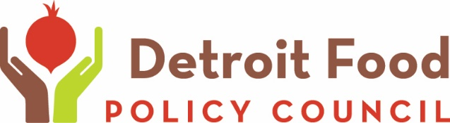
Contact Winona Bynum  Telephone 313-833-0396  Email winona@detroitfoodpc.org  Website Detroitfoodpc.org | FOR IMMEDIATE RELEASE  January 17, 2017

DFPC Welcomes CIVIL RIGHTS LEADER SHIRLEY SHERROD

Detroit, MI, January 17, 2017– The Detroit Food Policy Council will host a visit from Shirley Sherrod, executive director of the Southwest Georgia Project for Community Education. The SWGP, as it is known, exists to ameliorate social inequities, persistent poverty rates, high unemployment rates and to combat historically negative agriculture-related experiences for minorities.
“Shirley Sherrod is an inspiring figure in the quest for equity in agriculture,” says Detroit Food Policy Council Executive Director Winona Bynum. “It’s an honor to have her here in Detroit.”
Sherrod has remained at the forefront of efforts to fight institutional racism, while promoting empowerment strategies for economically and socially disadvantaged people. She made news in 2010 when she ran afoul of a website run by the late Andrew Breitbart, whose eponymous website is popular among devotees of the “alt-right.” Comments she made were significantly edited to change the meaning, leading to the USDA to ask for her resignation and later rescind the request when the full film clip came to light. A lawsuit with Breitbart and his heirs was later settled out of court.
TIME: 9:00 AM
DATE: JANUARY 25, 2017
WHERE: Sacred Heart Church, 1000 Eliot, Detroit 48207
RSVPs requested: https://www.flipcause.com/secure/cause_pdetails/MTQ3NzE=

Parking is available at the church. Breakfast will be served.
The Detroit Food Policy Council was established in 2009 by unanimous approval of The Detroit City Council. The DFPC is an implementation, monitoring and advisory body and consists of twenty-one members, including thirteen (13) representatives from various sectors of the Food System, four (4) "at-large" representatives, one (1) youth representative and three (3) governmental representatives, one each from the Mayor's Office, City Council and The Department of Health and Wellness Promotion (DHWP).
DFPC is committed to nurturing the development and maintenance of a sustainable, localized food system and a food-secure City of Detroit in which all of its residents are hunger-free, healthy, and benefit economically from the food system that impacts their lives.

# # #
If you would like more information about this topic, please contact Winona Bynum at 313-833-0396 or email at winona@detroitfoodpc.org.

