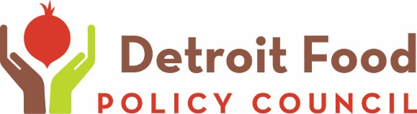

Detroit Food 2017 Scholarship Request Form
March 9-10, 2017
Benson and Edith Ford Conference Center
460 W. Baltimore Ave, Detroit, MI 48202

The Detroit Food Policy Council grants scholarships to Detroit residents who would not otherwise be able to attend the Detroit Food Summit. If you would like to request a scholarship please submit the scholarship request form by Monday, February 27. Scholarships will be given on a first come first serve basis.

Name
Address
City |  | State | Zip
Phone | ☐Home  ☐Cell  ☐Work | Phone |  | ☐Home  ☐Cell  ☐Work
Email
Organization/Company Or N/A

When your scholarship request is approved you will be contacted by email with a registration code. If email is not a good way to reach you please indicate how you would like to be contacted below. You must fill out the registration form to attend the Summit, please request a registration form by mail below if you cannot complete the registration form online.
Contact me by email with registration information ☐Yes No, please contact me by
☐Phone ☐Mail
I can fill out the registration form online ☐Yes No, please contact me by
☐Phone ☐Mail

Please email the completed form to Olivia Henry at olivia@detroitfoodpc.org.
If you have any questions or for more information contact Olivia Henry at olivia@detroitfoodpc.org or 313-833-0396.

